History of Making Paint

Prehistoric Paintings
The prehistoric palettes of paints were all made from pigments obtained from the earth. The earliest pigments were earth pigments (ochre and umber), charcoal (carbon black and bone black), and white (calcium).

Ochre’s:
Red-Ochre: made from a mineral oxide of iron called hematite
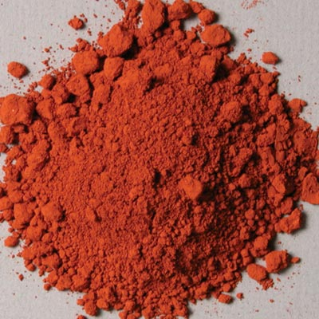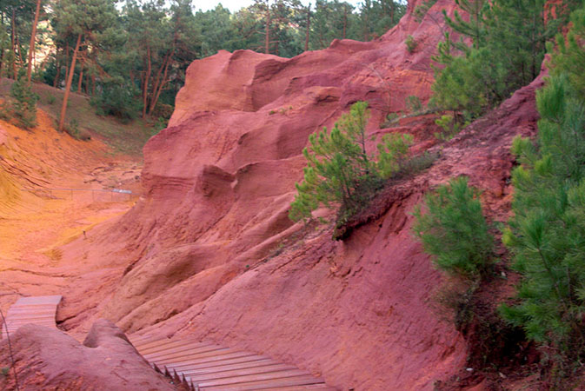

Yellow- Ochre: a hydrated form of iron oxide that turns the soil yellow.
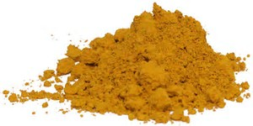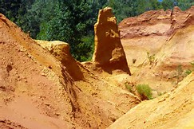

Charcoal: carbon black is a black pigment obtained from partially burning wood.
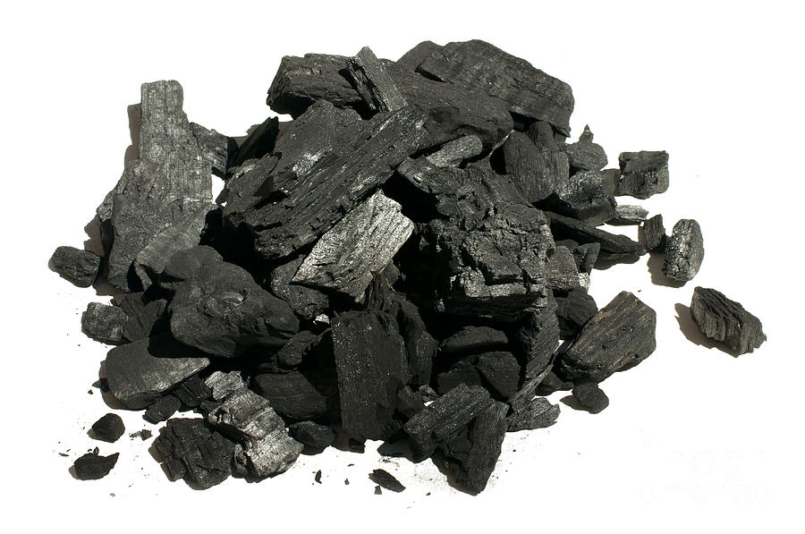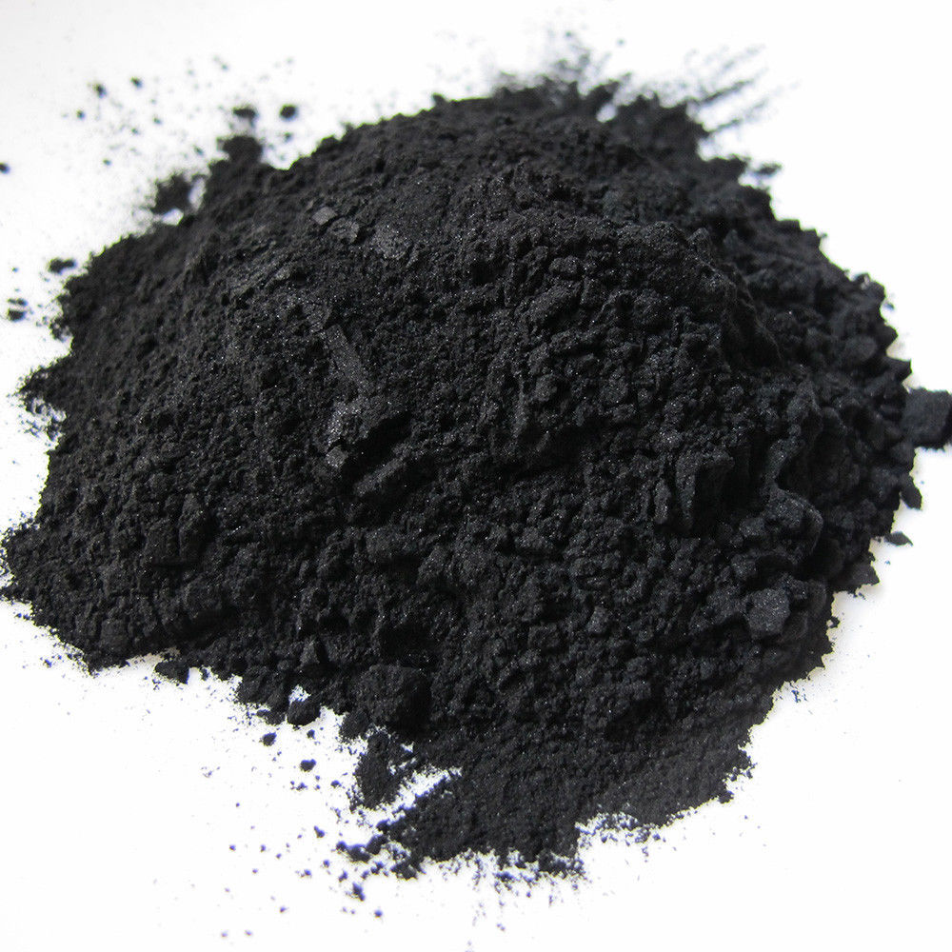

Umber: is derived from a clay containing iron and manganese oxides. Named after Umbria, the part of Italy from where it is was originally extracted from.
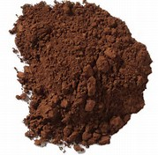

Medieval Age Paintings (5th – 15th CENTURY)
Painting had become a highly technical form of art by the medieval ages. A new medium used during this time called egg tempera was made by mixing pigments with water and egg. This mixture had a very short shelf life but it allowed the artist to develop new effects that were never seen before. The meticulous process of applying paint in thin layers to prevent it from cracking is why medieval painting has a highly polished finish.
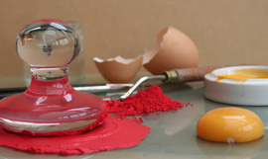

Renaissance Paintings (15th – 17th CENTURY)
A great number of techniques were a product of the Renaissance. Instead of using egg as a base for pigment, artists began to use linseed or walnut oil, which dried more slowly. Since paint took longer to dry, artists now had the luxury to experiment with depth and perspective, but more importantly they began to mix different paints to make new shades and hues.

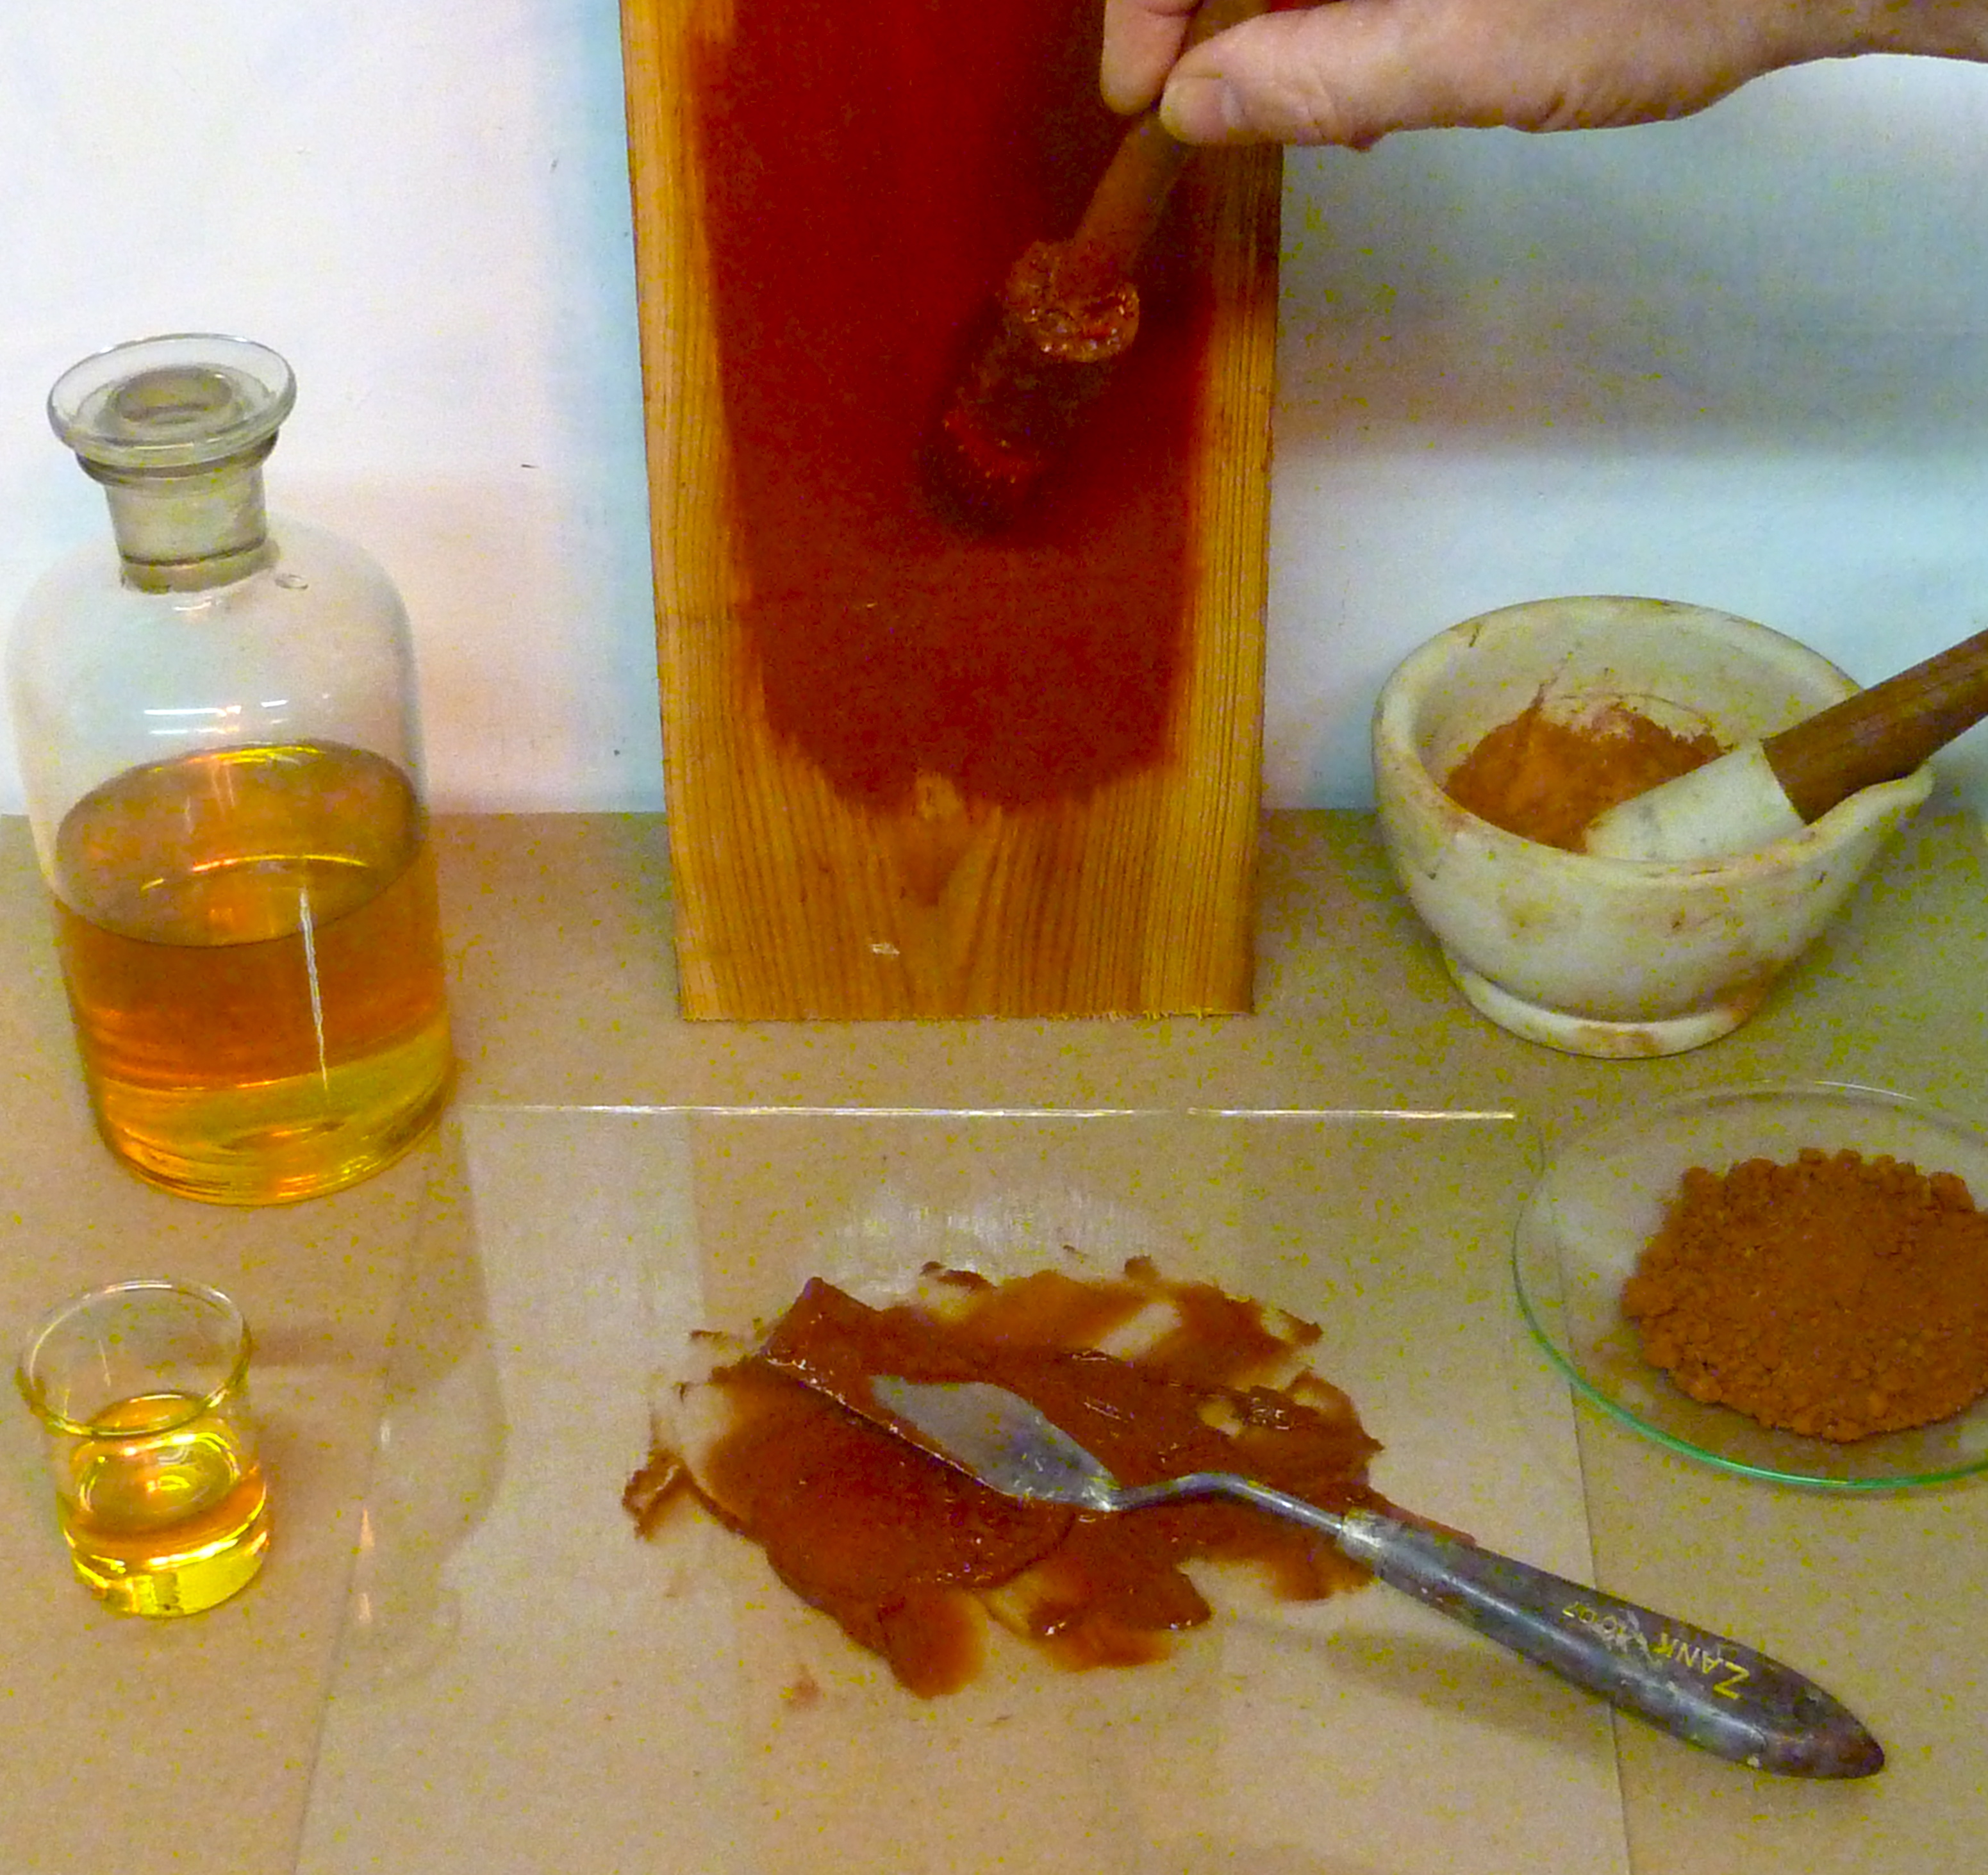

Modern Age Paintings (18th CENTURY)
Up until the modern age mostly the artists themselves made paint. Watercolor became popular when art became a hobby of the wealthy. In 1776 William Reeves began a company that produced cakes of watercolor. In his process he realized that the cakes of color he produced could be kept from cracking by adding small amounts of honey into the formula. By the early 1700s producing paint became a profession.

