Name__________________________________ Date_________
Lab # _______ Period_______

Populations Densities at Black Rock Forest

Background

A population is a group of individuals of the same species which inhabit a particular space at a particular time. The number of individuals in a population never remains constant. It may increase or decrease due to many factors like birth rate, death rate, migration, and available resources, etc. An environment can successfully support a certain number of individuals of each population. The number of individuals in a population in a certain area is known as the population density. The largest population density that a certain environment (area) can support is called its carrying capacity.

Biologists often attempt to measure the population densities of an area. Although fluctuations in population density are normal, substantial changes can indicate a severe problem—one that could harm the whole community. Human interference in the natural balance of biological communities has often resulted in unexpected and undesirable consequences. Today we will be studying the populations of three different types of plants at Black Rock Forest in various locations.

Pre-Lab questions

- Define, in your own words, the density of a substance? What is population density?
______________________________________________________________________________________________________________________________________________________________________________

- A quadrat is an area of land for ecological study. How large of a quadrat are you going to make? How are you going to divide your quadrat into smaller sections?
_____________________________________________________________________________________________________________________________________________________________________________________________________________________________________________________________________

- List 3 things that regulate the size of a population.
______________________________________________________________________________________________________________________________________________________________________________

Materials

Meter stick, popsicle sticks, string, pencil, paper

Hypothesis
____________________________________________________________________________________________________________________________________________________________________________________

Procedure
Part 1
One way to measure the population density of an area is to divide the area up into smaller areas called quadrats. The number of organisms in each quadrat is counted. The numbers are added up and then divided by the combined area of the quadrats to calculate the population density.

Population density = Number of individuals
Total area

A biologist first decides on the area to be studied. The size of the quadrat is then determined. They can be large or small, depending on the organisms being studied. (For example, the population density of raccoons in a forest could not easily be measured in quadrats of 1 square meter. Much larger quadrats would be used.)

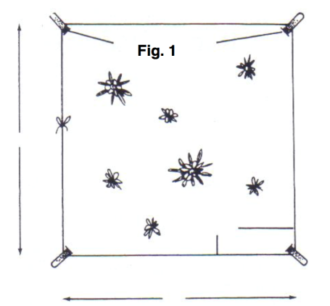
You will determine the population densities of three kinds of weeds in an area by studying 3 different quadrats that are 1 square meter and pooling your results with those of your classmates.

- Go to the first location that your teacher assigns. Pick a spot randomly and set up a quadrat of 1 square meter. Measuring carefully, place four stakes (Popsicle sticks) 1 m apart at the corners of the square. See Figure 1.
- Then tie a piece of string around the perimeter of the quadrat.
- Draw the quadrat to scale in Figure 2 below. The box below has 10 cm sides so your drawing will be on a scale of 1:10. Include in your diagram physical features such as rocks or trees that happen to fall within your sample plot.
- Location 1 ____________________ Describe your first location. Explain what abiotic factors you observe. ____________________________________________________________________________________________________________________________________________________________________________________________________________________________________________________________________________________________________________________________________________________________

Figure 2: Overall view of Quadrat 1

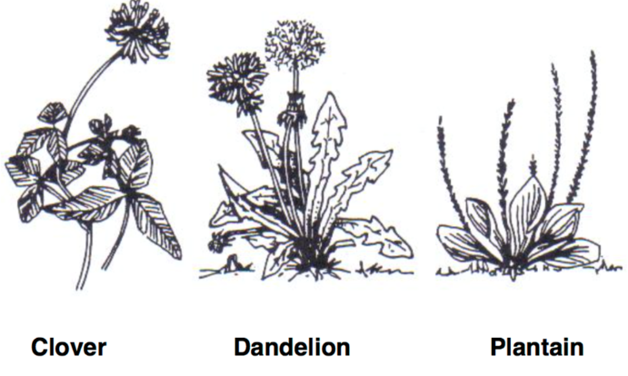

- Study Figure 3 so that you can recognize dandelion, plantain, and clover plants.

Figure 3
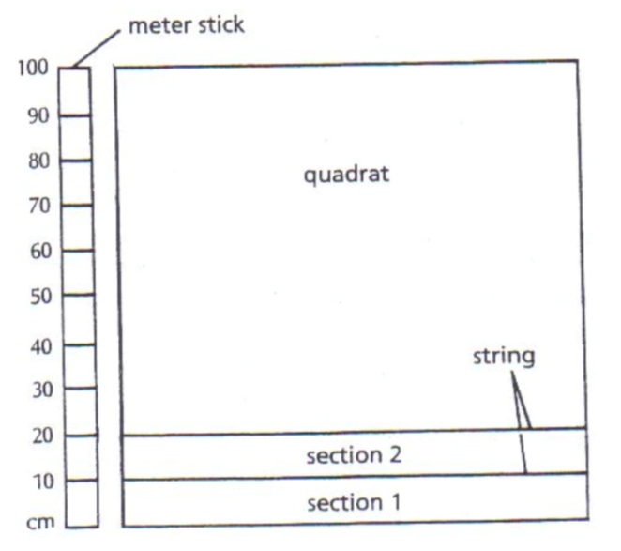
- To count the plants in your quadrat accurately, you will have to divide the quadrat into smaller areas. Lay the meter stick along one side of the quadrat. See Figure 4. Lay a piece of string across the quadrat 10 cm from the boundary. Count the number of dandelion, plantain, and clover plants in section 1 of the quadrat. Continue this process until all 10 sections are counted.
Figure 4

- Record your data in data table 1.
Section | Dandelion | Plantain | Clover
1
2
3
4
5
6
7
8
9
10
Total

Table 1:
Number of plants in Quadrat 1

Figure 5

Symbol | Plant
Δ | Dandelion
Ο | Plantain
+ | Clover
- Using the symbols shown in Figure 5, plot the approximate locations of the weeds on your quadrat drawing from figure 2. In addition, you will come across other species of plants. Using numbers, plot the approximate locations of these other plants. For example, 1 represents one species of plant. Draw in “1”s wherever you see that plant in your quadrat. If you identify another species, draw “2”s wherever you see that plant, etc.

- Repeat steps 1 through 8 at the other location on our trail.

- Location 2: ____________________________
Description of location: ________________________________________________________________________________________________________________________________________________________________________________________________________________________________________________________________________________________________________________________________________________________________________

Figure 6: Overall view of quadrat 2

Section | Dandelion | Plantain | Clover
1
2
3
4
5
6
7
8
9
10
Total

Table 2: Number of plants in quadrat 2

- Record the class totals in Table 3.
- Once all the class data is copied, add the columns to get the class totals for each plant. Divide each total by the number of groups in the class to calculate the population densities of the three types of plants (plants/m²).

Table 3. Population Densities of Plants in a Community

Class Group | Dandelion (total) | Plantain (total) | Clover (total)
1
2
3
4
5
6
7
Total
Population Density

Analysis and Interpretation:
- Why is the class average a better measure of population density than an individual quadrat? ______________________________________________________________________________________________________________________________________________________________________

- What environmental factors might affect the densities of the dandelion, plantain, and clover populations? ______________________________________________________________________________________________________________________________________________________________________

- Were there any observations you made in regards to certain abiotic factors that may have affected the densities of the three species of plants? ____________________________________________________________________________________________________________________________________________________________________________________________________________________________________________________________________________________________________________________________________________

- How would you measure the density of a mobile population, such as mice on a prairie or fish in a pond? ______________________________________________________________________________________________________________________________________________________________________

- What happens if the population density of an organism increases beyond the limits of its food supply? ______________________________________________________________________________________________________________________________________________________________________

Part 2. Balance of Population Densities in a Community

The size of populations in a community is regulated in many ways. The story of the Kaibab deer shows how populations were balanced in one community and how humans upset this natural balance. In the early 1900s, the Kaibab plateau, north of the Grand Canyon in Arizona, supported a population of about 4,000 deer on over 700,000 acres. Predators, such as the coyotes, wolves, and pumas, helped to keep the deer population in check. It was estimated at that time that the plateau had a carrying capacity of about 30,000 deer, so that there seemed to be plenty of food for the population that existed. Ranchers who moved into the area lost many sheep and cattle to predators. In an effort to save livestock and increase the deer population the predators were hunted. With the successful removal of many of the natural predators, the deer herd increased dramatically in size. In 1924 there were 100,000 deer, as shown on the graph on the following page. As a result, 40,000 deer died in 192 from starvation and disease. The population continued to decrease over the ears and in 1940 returned to near its original level.

- Examine the graph below.
- Determine the approximate population density in deer/1,000 acres for each year below.
Example for 1900: 4,000 deer X # deer = 5.7 deer/1,000 acres
700,000 acres 1,000 acres

1905: ________________________
1915:________________________
1920:________________________
1925:________________________
1930:________________________

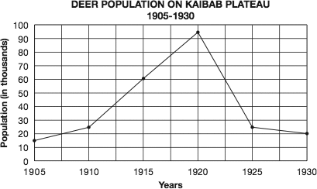

Analysis and Interpretation:

- What would be the population density of deer at the Kaibab plateau’s carrying capacity (30,000 deer)?

- Explain the substantial increase in the deer population from 1905 to 1924.

- Name some factors that contributed to the substantial change in sizes of the deer population from 1925 to 1930.

- What role do predators play in a biological community? Why are they necessary for the balanced community?

- What happens if the population density of an organism increases beyond the limits of its food supply?

- What steps could have been taken to maintain the number of deer at the 1915 level?

- What changes in the community do you think occurred as the deer population increased?

