HMS Team 7B
Cookies and Canvas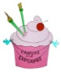
With Ms. McCarthy!
Friday, Feb 28th 6:30-8:00
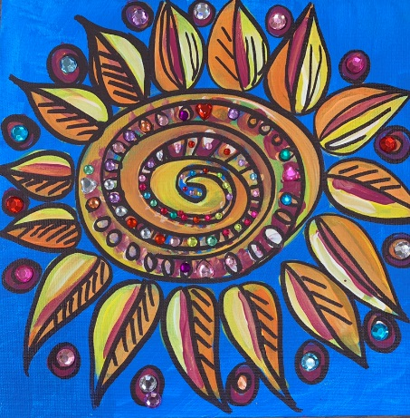
$20 per person includes cookies, beverages, and painting materials
All skill levels are welcome!
Advanced Reservations are required!
There are 60 spaces/canvases available.
Spaces are allocated at a first come, first served basis.
Please print clearly. One form per Family. All children MUST be accompanied by an adult- no drop offs.
HMS Students Name: _______________________________________________________
Grade ________________ Team _______________8th period teacher ________________
Adult’s Name __________________________Phone _______________________________
Canvases requested 1 2 3 4 5 Enclosed Amt: ___________________________($20 p/p per canvas)
To guarantee your canvas, please send your payment and the form in a sealed envelope.
Please label the envelope HMS Team 7B Cookies and Canvas. Please make your check payable to NECSD
Space is limited, return your form with payment today.
We’re sorry but we cannot accommodate siblings younger than 9 years old.
Money raised will go to supplement activities for team 7B

