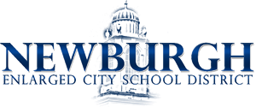

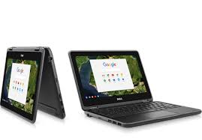
Logging into an NECSD Chromebook

1) Username and Password
When your chromebook powers up, you will be required to enter your NECSD username and password.
Username: (FIRST INITIAL) (LAST INITIAL)(LAST 4 DIGITS OF ID NUMBER)
- Example:
  - FIrst Name: Bob
  - Last name:Turner
  - Student ID: 201234
  - Username would be: bt1234
Password is what you use to log onto the NECSD launchpad at school unless you have made changes to it.
2) In the lower right hand corner the following is found:
- Battery Level
- Wifi Connection
- Bluetooth
- Keyboard Language Modifier
In the lower left hand corner the following is found
- Search bar
  - Searches the web and computer for information and specific documents.
3) Connecting to WIFI at Home
- In the bottom right hand corner of your screen, click the oval box with the time and battery level indicators. The wifi signal symbol will be there. 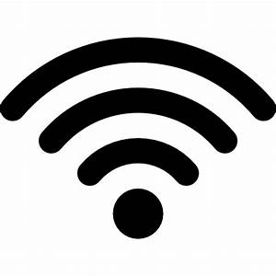
- Click the symbol that shows WIFI and choose network from given list.
- Enter the Password for your network and then you are connected.
4) Accessing School account at home
- Go into chrome and enter https://launchpad.classlink.com/necsd or access launch pad from the Newburgh Schools Website https://www.newburghschools.org/
- 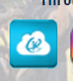 This is the launchpad symbol on the NECSD website
- When you get to the next screen, enter the Username and Password that you use to log onto the computer
- This will give you access to NECSD resources, including your Google Account
- Be sure to sign into the launch pad and agree with the Google policies - if you are asked for username and password again please enter your credentials once more to verify .
- You should now be logged in .
- Be sure to log off when you are finished using the device ,

