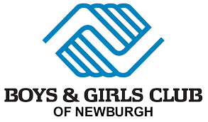

21st Century Afterschool Program: Educator Bios

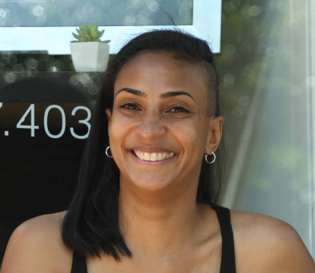
Angela Paul-Gaito

Angela Paul-Gaito, owner and Pilates instructor at APG Pilates in Newburgh, moved from France to become a certified student from the Alvin Ailey school. She performed around the world as a freelance dancer for various companies, theaters, and TV projects. She became truly involved with the Pilates method after her first pregnancy to reconnect to her body. Angela is trained by Balanced Body and became certified by Polestar Education in 2009. In 2015, she started her bridging program at Beacon Pilates to improve her practice and knowledge on the Classical form of the Pilates method. Angela has been also working at “Pilates Reforming NY” in New York City where her clients have included Broadway performers, Radio City Rockettes, and prize NYC marathoners. She also offered several workshops in France and taught for the Alvin Ailey Dance Company during their French tour.

Angela has been teaching in the Hudson Valley since 2009. She opened her studio in Newburgh in 2012 and has been located across from Washington Headquarters on Liberty Street, since March 2014. Angela is also a Newburgh Performing Arts Academy dance teacher since 2016.

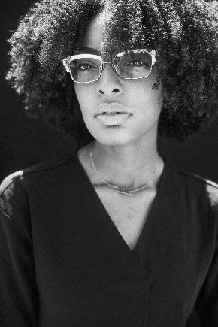
Khalidah Carrington
Khalidah Carrington is a 26-year-old freelance artist based in Newburgh NY.
Within the past 6 years, Carrington has honed her skills in building brand identifications, curating sets, and design props for short films, and creating personal works that have pushed her boundaries as a creator.
Carrington hopes to one day create her own Co-working space geared towards artists, and creatives of color; with a focus on providing them the resources they need to jump-start their creative careers.

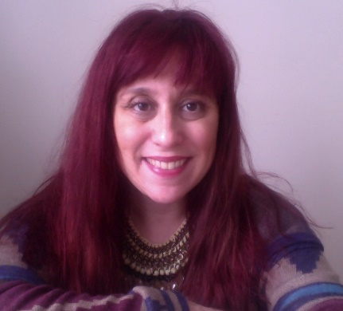
Cari Skier
Cari is a mixed media artist whose mediums include painting, graphic design, and clothing design. She enjoys using a myriad of materials and being unpredictable in her creative process. Cari graduated from Mason Gross School of the Arts with a Bachelor of Fine Arts and went on to receive her Masters in Education. She is a certified k-12 special and art educator and was an adjunct art professor at Bloomfield College, New Jersey.
Cari has been teaching art workshops to children and adults for over 20 years. Her artwork has been displayed in galleries and shops throughout New York, New Jersey, and Pennsylvania. She has work published in both Somerset Studios and Altered Couture Magazines. Much of her early work has been seen in commercial products such as books, album covers, murals, and corporate design.

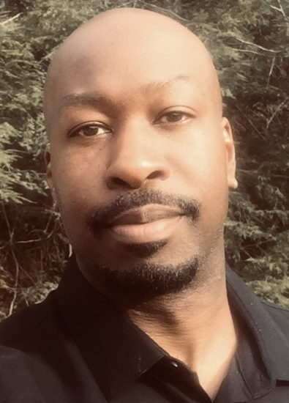
Ammon Archie
Ammon Archie is a multidisciplinary visual artist and arts manager currently based in the Hudson Valley, NY. His artworks are created in a variety of artistic mediums and surfaces including drawings and paintings in charcoal, acrylic, house paint, and airbrush on 2D traditional surfaces and on 3D sculptures. Ammon holds a Bachelor of Fine Arts Degree in Illustration from Montserrat College of Art in Massachusetts. He also holds a Master of Professional Studies Degree in Arts and Cultural Management from Pratt Institute in NYC. He has worked with a variety of companies and creative studios throughout New York and New England and applied his talents in several industry disciplines including, art restoration, product development, and the scenic arts. Ammon is also passionate about community and personal development and enjoys working with arts councils and local agencies to develop art venues, and workshops that inspire creativity, appreciation of diversity, and artistic exploration.

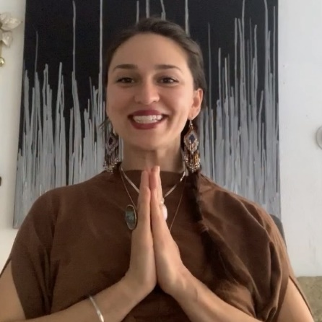
Anusha Mehar
ANUSHA MEHAR left the womb musing in poetic tongues. She is a seasoned Storyteller with 10+ years of experience working as an Educator, Cultural Organizer, Poet, Producer, and Leader in the non-profit sector. Her experience is rooted in working both locally and internationally with youth, women, immigrants, and other underserved populations to shift narrative through multi-media & movement trainings, restorative justice circles, mindfulness workshops, and public art interventions. She holds a BA from CUNY Hunter in Spanish Language Arts and Literature, marrying her loves of art, history, and storytelling—passions that have excited her since she was old enough to read. She employs these skills as the Creatrix of PANJA, a culture + wellness studio with a holistic approach to harmonizing mind, body, and spirit medicine. From the PANJA HQ, she spearheads interdisciplinary programming and operates her somatics studio, focused on reframing how we hold story in the body. Her mantra is "Liberation > Everything," and she strives to be a part of the solution in all of her endeavors. Find more about Anusha's work at panjaculture.com.

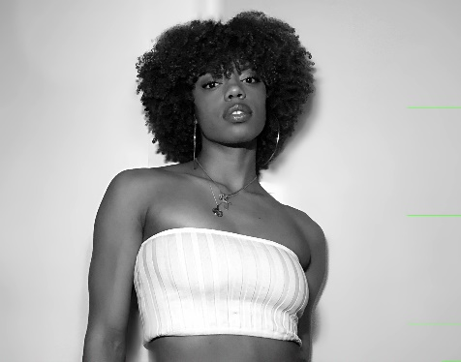
Maya Llanos

From a very young age, Maya was always surrounded by various forms of artistic expression. With her father as a professional DJ and mother as a professional dancer and educator, naturally, she was drawn to music, dance, and martial arts. Currently signed to Clear Talent Group, Maya has been blessed with several opportunities & performances which have included: Black Girls Rock Award Show, NIKE, Madonna, GEICO, Jimmy Fallon, MAC Cosmetics, Desigual New York Fashion Week, and more. Grateful for all the blessings that have come her way, the most rewarding gift for her is to continue growing as an artist and inspiring others to achieve anything they set their mind to.

