What is Pigment?
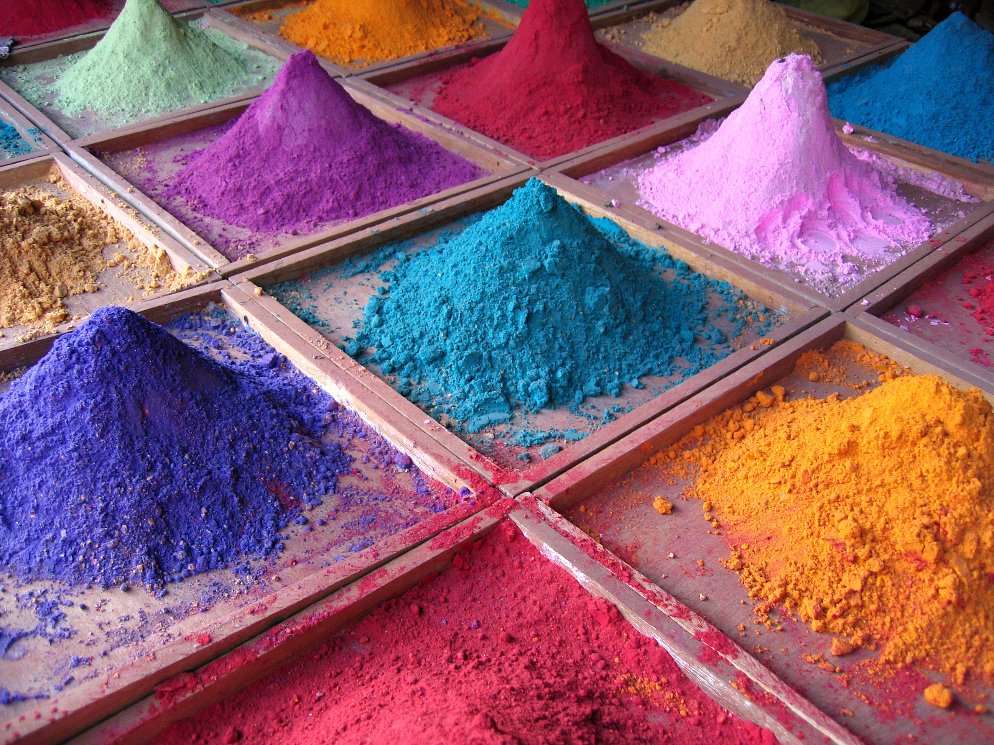

Definition of Pigment:
All paint is made from an essential ingredient known as pigment. These tiny particles are ground colored material. They were first extracted from earth or clay. Even though we continue to use age-old processes to prepare pigments and convert them into paint, modern pigments are synthesized in laboratories.

The following properties are taken into consideration when talking about the quality of both synthetic and natural pigments:

Light fastness: the rate at which a pigment fades when exposed to light.
Heat stability: how pigments react when exposed to heat.
Toxicity: the degree to which it can damage a living or non-living thing.
Tinting strength: how much pigment is required to produce a particular shade.
Opacity or transparency: whether one can easily see the under layers of paint once the top layer is dry.

RED
Vermilion is an opaque orange-red pigment that occurs in the mineral cinnabar. It is one of the oldest used colors in the world as cinnabar is a common mineral found around the world. The mineral is ground into a fine powder and heated with mercury and sulfur before it is ready to be mixed with a paint-base. However it is also used without these chemicals, like in India, where married women use sindoor, a red streak of vermilion in the parting of their hair.
Carmine, also known as crimson lake or cochineal red, is a bright red color derived from the aluminum salt of carminic acid. This might sound complicated, but this acid is found naturally in the cochineal insect. The insects are dried and boiled in water to release the pigment. The water is then treated with a chemical to make this liquid into a powdered pigment.
Madder lake sounds like the name of a body of water in a fairytale but in fact is the name of a pigment that has been used for centuries. This natural pigment is extracted from the roots of plants of the ‘madder’ family. The outer brown layer of the root gives a common variety of the dye while the inner yellow layer turns bright red when fermented.

GREEN
Malachite is used in the production of green pigment much in the same way as Ultramarine. This copper carbonate mineral occurs naturally in the Ural Mountains of Russia, many parts of Africa, France, Italy and the United states.
Paris green is an inorganic compound of copper. This poisonous substance is named Paris green because it was used to kill the rats in Parisian sewers. The compound can be ground into a fine powder to produce a lighter, vivid green, or left a little coarser for a darker shade. It is used even today in paint production despite its high toxicity.
A highly expensive green pigment is Cobalt green, made from the element from which it gets its name. The green extracted from cobalt fades very easily when exposed to light. The high cost and because it fades easily is the cause for its disuse. However, scientists found that cobalt has certain magnetic properties that have increased the efficiency of computer storage devices.

YELLOW
The color India yellow used to be produced by collecting cow urine of cattle that had only been fed mango leaves. The urine was collected in pots and heated over a fire. The concentrate was filtered and the remaining sediment was made into balls, then dried and then made into yellow paint in Europe. It was a preferred shade of yellow because of its fluorescent hue.
Naples yellow, also known as antimony yellow, is one of the oldest synthetic pigments around. The old masters of Europe used this pigment extensively, but is not used anymore, because it is very toxic. The color gets its name from the natural deposits of lead antimonite, which was extracted from Mt. Vesuvius, just outside of Naples.
Hansa yellow is a synthetic pigment used in inks, and oil and acrylic paint. It was first made in Germany just before WWI and has replaced its predecessors such as Cadmium yellow, chrome yellow, orpiment, and gamboge because it is not toxic.

Published by mocomi.com

