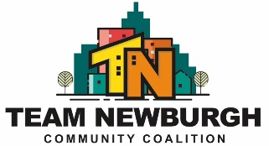
TEAM NEWBURGH CAN H ELP WITH YOUR PRESCRIPTION DRUG STORAGE AND DISPOSAL.
We have been working with the NECSD to provide the Health Offices with these items and would like to offer them to families of students as well.
We can provide *Lock bags (to store prescriptions safely)
Lock caps (with combination)
Drug destruction products (Dispose RX or Deterra to safely
dispose of unneeded prescriptions).
Prescription Trackers-to keep track of when prescriptions
were taken.
There is also a drop box in the lobby of the City of Newburgh PD for unneeded or expired prescriptions which can be accessed 24/7 no questions asked.
Please contact NECSD Health Services Facilitator, Ms. Sharon Patsalos at 845-563-3497 to get any of these items for your home.

